|  |
| --- |
| **Introduction** |
|  |

|  |  |
| --- | --- |
|  | Microsoft Excel is a spreadsheet application that provides simple to advanced means of creating and managing any type of list. To enhance it beyond its default function, it ships with a language called Microsoft Visual Basic or simply Visual Basic.  Microsoft Visual Basic for Applications (VBA) is a computer language based on Microsoft Visual Basic. It allows you to write code that can automatically perform actions on a document and/or its content. When using that language, you write pieces of code, using an external environment. |

Microsoft Visual Basic is a programming environment that gets automatically installed when you set up Microsoft Excel. It stays apart because most people would not need or use it. This means that if you want to use the Microsoft Visual Basic programming environment that ships with Microsoft Excel, you must ask for it, which can be easily done.

|  |
| --- |
| **Launching Microsoft Visual Basic** |
|  |

In our lessons, we will learn how to use both Microsoft Excel and Microsoft Visual Basic to create and manage spreadsheets. The Microsoft Visual Basic programming environment we will use depends on Microsoft Excel. As a result, to use Microsoft Visual Basic, you must first open Microsoft Excel. Then, to write code, you must open Microsoft Visual Basic. There are various ways you can do this, depending on your intention.

Before using code, you should add a new tab, the Developer tab, to the Ribbon. To do this, you can click the Office Button and click Excel Options. In the Excel Options dialog box, click the Show Developer tab in the Ribbon check box and click OK. The Ribbon would become equipped with a new tab:

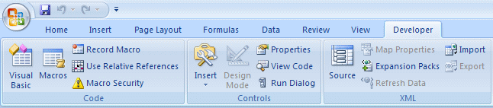

From the Developer tab of the Ribbon, to launch Microsoft Visual Basic, you can click the Visual Basic button .

|  |
| --- |
| **Practical Learning: Starting Microsoft Visual Basic** |
|  |

1. Start Microsoft Excel
2. Click the Office Button and click Excel Options
3. In the Excel Options dialog box, click the Show Developer tab in the Ribbon check box:  
      
   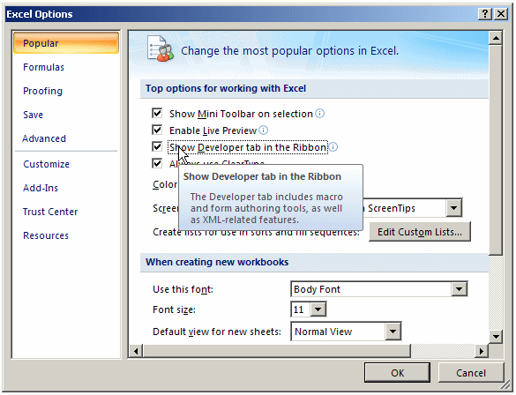
4. Click OK
5. In the Code section of the Developer tab of the Ribbon, to launch Microsoft Visual Basic, click Visual Basic:  
      
   Graphical user interface, application, Word

   Description automatically generated

|  |
| --- |
| **The Microsoft Visual Basic Interface** |
|  |

|  |
| --- |
| **Introduction** |
|  |

When it opens, like any regular Windows application, Microsoft Visual Basic displays a title bar in the top section. Under the title bar, the application displays a menu, followed by a Standard toolbar.

To assist you with your development, Microsoft Visual Basic can display various windows.

|  |
| --- |
| **The Project Explorer** |
|  |

The Project Explorer window shows a list of the code segments that are available to your worksheet. It is usually available whenever you open Microsoft Visual Basic. It is usually positioned in the top-left section. If it is not present, to display it, on the main menu of Microsoft Visual Basic, you can click View -> Project Explorer. To close it, you can click its Close button .

You can move the Project Explorer to another section of the interface. To do this, click its title bar and  drag it away it from there:

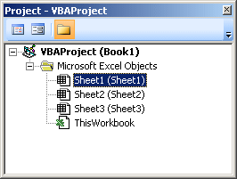

To put the window back where it was previously, you can double-click its title bar.

|  |
| --- |
| The Project Explorer |
|  |

The Properties window is usually positioned in the bottom-left section of the screen. When it does not appear, to display it, on the main menu, click View -> Properties Window:

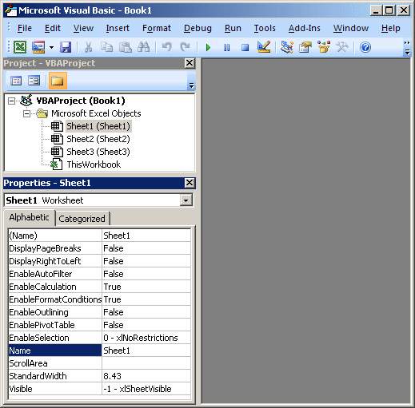

The Properties Window shows the characteristics of an object that is selected. Like any other window, to move the Properties window from its position, drag its title bar:

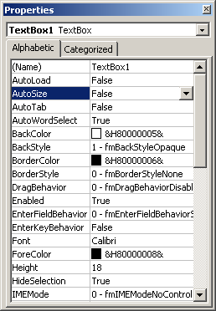

The main area of Microsoft Visual Basic uses a gray background. This area is gray because, in reality, Microsoft Visual Basic is a multiple document interface (MDI) that can be used to display various windows at the same time. At times, this gray area will be occupied with other windows.

|  |  |  |  |  |  |  |  |  |  |  |  |  |  |  |  |  |  |  |  |  |  |  |  |  |  |  |  |  |  |  |  |  |  |  |  |
| --- | --- | --- | --- | --- | --- | --- | --- | --- | --- | --- | --- | --- | --- | --- | --- | --- | --- | --- | --- | --- | --- | --- | --- | --- | --- | --- | --- | --- | --- | --- | --- | --- | --- | --- | --- |
| Modules  A module is a blank window that resembles a piece of paper on which you write code. When you use Microsoft Excel and work on a document, a default module is automatically allocated for it, whether you use it or not. You can also create a module that is independent of any worksheet.  To create a module, on the main menu of Visual Basic, you can click Insert -> Module.   |  | | --- | | Practical LearningPractical Learning: Creating a Module | |  |  1. On the main menu of Microsoft Visual Basic, click Insert -> Module 2. Notice that a blank window with a blinking caret appears   Microsoft Visual Basic  |  | | --- | | The Immediate Window |   To help you test code, Microsoft Visual Basic provides a special window called the Immediate Window. To display it, on the main menu of Microsoft Visual Basic, you can click View -> Immediate Window.   |  | | --- | | Practical LearningPractical Learning: Displaying the Immediate Window | |  |  1. To display the Immediate Window, on the main menu of Visual Basic, click View -> Immediate Window 2. Notice that a window with an Immediate title bar appears at the bottom with a blinking caret   The Immediate Window 3. To return to Microsoft Excel, on the Standard toolbar of Visual Basic, click the View Microsoft Excel button 4. To close Microsoft Visual Basic, on the main menu, click File -> Close and Return to Microsoft Excel  |  | | --- | | **VBA in Visual Basic** | |  |      |  | | --- | | **Introduction** | |  |   In the spreadsheet you will create, you use Microsoft Excel to create normal documents using the default settings of the application. To apply some advanced features to a spreadsheet, you can use Microsoft Visual Basic that is automatically installed with Microsoft Excel.  To create a spreadsheet with functionality beyond the defaults, you write code. Microsoft Visual Basic is a programming environment that uses a computer language. That language is called Visual Basic for Applications (VBA). Although VBA is a language of its own, it is in reality derived from the big Visual Basic computer language developed by Microsoft. In our lessons, we will learn how to use VBA in Microsoft Excel.  To take advantage of the functionalities of the Microsoft Visual Basic environment, there are many suggestions you can use or should follow. Because VBA is normal computer language, there are various rules you must follow for the language to work.   |  | | --- | | **Using VBA** | |  |   In our lessons, we will use the word VBA sometimes but most of the time, we use the expression "Visual Basic Language". When we use "Visual Basic language", we refer to a concept that is recognized by all child languages of Visual Basic, including VBScript and VBA. When we will use the word VBA, we refer to a concept that either is proper to VBA as a language and is not necessarily applied to some other flavours of Visual Basic, or to the way the Visual Basic language is used in Microsoft Excel. For example, the word **String** is used in all Visual Basic languages but the word **Variant** is not used in the 2008 version of the Visual Basic language.   |  | | --- | | **Macros** | |  |      |  | | --- | | Creating a Macro |   To launch Microsoft Visual Basic using the default installation of Microsoft Excel and launching from a macro:   * On the Ribbon, you can click View. In the Macros section, click the arrow under the Macros button and click Record a Macro:     Record Macro   * Click Developer. In the Code section, click the Record Macro button   In each case, the Record Macro dialog box would come up:  Record Macro  On the Record Macro dialog box, accept or enter a name for the macro. As an option, you can type a description of the macro in the bottom text box. Once you are ready, click OK. This would bring you to the document in Microsoft Excel where you can do what you want.  After doing what is necessary, to end the creation of the macro, on the Ribbon:   * Click View. In the Macros section, click the the arrow of the Macros button and click Stop Recording:   Stop Recording a Macro   * Click Developer. In the Code section, click the Stop Recording button Stop Recording  |  | | --- | | **Practical Learning: Creating a Macro** | |  |  1. Start Microsoft Excel 2. On the Ribbon, click Developer. In the Code section, click Record Macro 3. Set the Name of the macro as **Variables**   Record Macro 4. Click OK 5. In the document, whatever box is selected (don't click any), type **=2** 6. On the Formula Bar, click the Enter button Enter 7. In the Code section of the Ribbon, click Stop Recording  |  | | --- | | **The Skeleton Code of a Macro** | |  |   When you create a macro, skeleton code is generated for you. To access the code generated for a macro, on the Ribbon:   * Click View. In the Macros section, click Macros Macros or click the the arrow of the Macros button and click View Macros   View Macros   * Click Developer. In the Code section, click the Macros button Macros   Any of these actions would open the Macros dialog box that would display the list of macros in the current document:  Macro  To see the code of a macro, click its name and click Edit.   |  |  |  |  |  | | --- | --- | --- | --- | --- | | |  | | --- | | Practical Learning: Viewing the Code of a Macro | |  |  1. To open Microsoft Visual Basic, in the Code section of the Ribbon, click Macros 2. In the Macros dialog box, make sure Exercise1 is selected and click Edit | |  | | --- | |  | | | |  | | --- | |  |  |  | | --- | |  | |  |  | | --- | | VBA in a Macro | |  |   We will try to reduce as much as possible the code that will be written for you. Still, there are some lines and words we will keep or use but will ignore them for now. As we move on in our lessons, you will understand what everyone of those words means. The code generated in the above Practical Learning section was:  Sub Exercise()  ActiveCell.FormulaR1C1 = "=2"  End Sub  The first line of code has the word **Sub**. We will introduce it later on. Exercise1 is the name of the macro we created. We will come back to names in a few sections in this lesson. We will also come back to the role of parentheses. The section of code ends with the **End Sub** line. We will come back to it when we study the procedures. For now, consider the **Sub** Exercise1() and **End Sub** lines as the minimum requirements we need as this time, that we don't need to be concerned with, but whose roles we can simply ignore at this time.  The most important line of our code, and the only line we are concerned with, is:  ActiveCell.FormulaR1C1 = "=2"  This line has three main sections: **ActiveCell.FormulaR1C1**, **=**, and **"=2"**. For now, understand that the **ActiveCell.FormulaR1C1** expression means "whatever box is selected in the document".  The = sign is called the assignment operator. As its name indicates, the assignment operator is used to assign something to another, to give a value to something, or more precisely to store something somewhere.  The thing on the right side of = is called a value. Therefore, "=2" is a value. Based on this, the expression **ActiveCell.FormulaR1C1 = "=2"** means "Assign the thing on the right side of = to the thing on the left side of =." Another way to put it is, "Store the value on the right side of the assignment operator to the selected box on the left side of the assignment operator." For now, until indicated otherwise, consider that that's what that line of code means.   |  | | --- | | **Using a Macro** |   After creating a macro, you can use it to see its result. This is also referred to as executing a macro or running a macro.  To execute a macro, on the Ribbon:   * Click View. In the Macros section, click Macros Macros or click the the arrow of the Macros button and click View Macros * Click Developer. In the Code section, click the Macros button Macros   In the Macro dialog box, click the name of the macro and click Run.   |  | | --- | | **Writing Code** | |  | | **Code Indentation** | |  |   Indentation is a technique that allows you to write easily readable code. It consists of visually showing the beginning and end of a section of code. Indentation consists of moving code to the right side.  The easiest and most common way to apply indentation consists of pressing Tab before typing your code. By default, one indentation, done when pressing Tab, corresponds to 4 characters. This can be automatically set using the Tab Width text box of the Editor property page in the Options dialog box. To change it, on the main menu of Microsoft Visual Basic, you can click Tools -> Options and click the Editor tab:  Options  If you don't want the pressing of Tab to be equivalent to 4 characters, change the value of the Tab Width text box to a reasonable value and click OK. Otherwise, it is (strongly) suggested that you keep to its default of 4 characters.   |  | | --- | | **Comments** | |  |   A comment is a piece of text in code that would not be considered when reading your code. As such, a comment can be written any way you want.  In the Visual Basic language, the line that contains a comment can start with a single quote. Here is an example:  This line will not be considered as part of the code  Alternatively, you can start a comment with the **Rem** keyword. Anything on the right side of **rem**, **Rem**, or **REM** would not be read. Here is an example:  ' This line will not be considered as part of the code  Rem I can write anything I want on this line  Comments are very useful and you are strongly suggested to use them regularly.  The code that was generated in our Practical Learning section contains a few lines of comment:  Sub Exercise1()  '  ' Exercise1 Macro  '  '  ActiveCell.FormulaR1C1 = "=2"  End Sub |